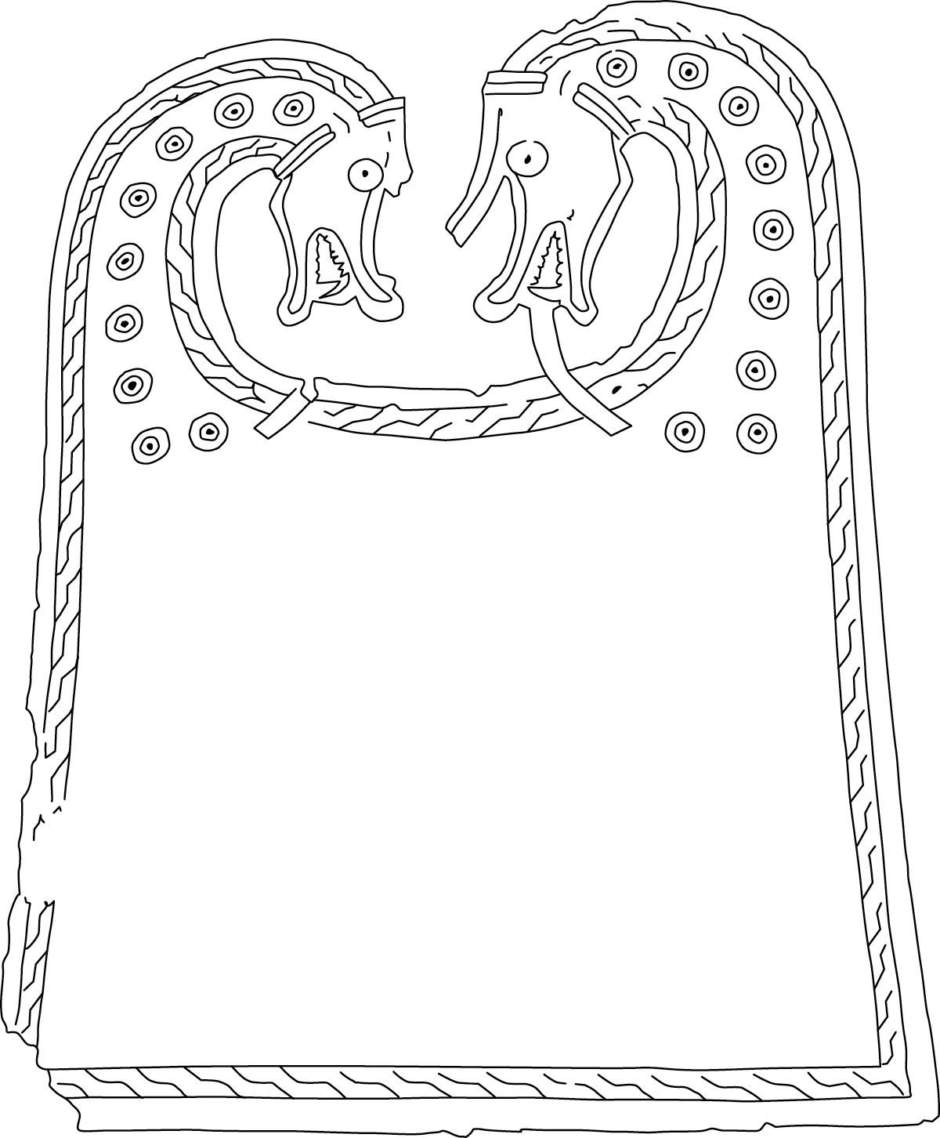

Burgers

Old Man of Hoy - £21.95
Steak mince beef burger, topped with haggis,
crispy onions and Orkney red cheddar, served in a brioche bun
with bacon and chorizo jam and peppercorn sauce,
served with chips or sweet potato fries (1,2,7,9,13,14)

Cheeseburger - £19.95 GF*
Steak mince beef burger topped with cheese and bacon,
served in a brioche bun with burger sauce, bacon and chorizo jam,
with chips or sweet potato fries (2,4,7,9,13,14)

Sweet Honey Mustard Chicken Burger - £18.95 GF*
Chicken burger marinated in sweet honey and mustard,
served in a brioche bun, with rocket leaves and ranch pickle mayo,
with chips or sweet potato fries (2,4,9,13,14)

Portobello Mushroom Burger – £15.95 V+ GF*
Portobello mushroom topped with sundried tomato pesto,
vegan feta and rocket. Served in a brioche bun,
with chips or sweet potato fried (2,10,13,14)

Upgrade your chips to Loaded Chips for just £3.50–£6.00 extra
Chips & Cheese - V (7,13)
Chips & Curry Sauce - V (2,13,14)
Mac ‘n’ Cheese Chips - V (2,7,9,13)
Chicken Fajita & Cheese Chips - (7,10,12,13,14) GF
Vegetable Fajita & Cheese Chips - V (7,10,12,13,14) GF
Vegan Fajita & Vegan Cheese Chips - V (10,12,13,14) GF
Haggis, Peppercorn Sauce & Crispy Onions - (2,7,13,14)

